    - Star Test

Ref: Chapter 11 of Malacara

The careful visual examination of the image of a point source formed by a lens being evaluated is one of the most basic and important tests that can be performed. The interpretation of the image in terms of aberrations is to a large degree a matter of experience, and the visual examination of a point image should be a dynamic process. The observer probes through focus and across the field to determine the type, direction, and magnitude of aberrations present. For ease of carrying out the test, the magnifying power should be such that the smallest significant detail subtends an easily resolvable 10 to 15 minutes of arc at the eye. It is also important that the numerical aperture of the viewing optics is large enough to collect the entire cone of light from the optics under test.

If the lens being tested is perfect, the image of a point source as seen at best focus is called the Airy disk. The Airy disk consists of a bright circular core surrounded by several rings of rapidly diminishing brightness. The diameter of the central core is equal to 2.44λf#, where f# is the f/number of the converging light beam. Note that in the visible, the diameter of the central core is approximately equal to the f# in microns. The central core contains approximately 84% of the total amount of light, while the total amount of light contained within the first, second, and third rings is approximately 91%, 94%, and 95%, respectively. If the microscope is moved back and forth along the axis, the image will be seen to go in and out of focus. The change in the pattern is rather complex, consisting first of a redistribution of light from the core to the rings, then with larger focus shifts the diameter of the image will appear to grow. A perfect image will appear totally symmetrical on opposite sides of focus as shown in Fig. 8.2.10-1.

Spherical aberration, coma, and astigmatism are also easily observed using the star test. The presence of spherical aberration is most easily inferred by examination of the symmetry of the image through focus. As one focuses on the image, starting from well inside the marginal image plane and moving toward paraxial focus, the following set of images shown in Fig. 8.2.10-3 is noted for undercorrected spherical. First, a diffuse, fairly uniform blur is seen. As the region of the marginal focus is approached, the beginning of the outer spherical caustic is reached. Here, a “hollow” or ring image is observed. Next, the ring diminishes in size and intensity and gives way to a core with a rather bright set of surrounding diffraction rings. Eventually, the size of this structure reaches a minimum and then becomes a small, intense core surrounded by a diffuse halo. Beyond the paraxial plane a growing diffuse flare is observed. The best focus (minimum spot size) occurs at ¾ the distance from paraxial to marginal focus. The minimum spot size is ¼ the spot size at paraxial focus.

Off-axis images are complex. Almost always, a mixture of coma and astigmatism of various orders is obtained. For third-order coma, the image looks much as indicated in Fig. 8.2.10-5, while the line foci for third-order astigmatism appears as indicated in Fig. 8.2.10-6. Fig. 8.2.10-7 shows the diffraction pattern for third-order astigmatism in the neighborhood of the circle of least confusion.

It is useful to obtain a rough estimate of the geometrical spot size produced by the different aberrations. Let ΔW be the maximum aberration for third-order spherical, coma, and astigmatism and f# be the f/number of the converging light beam. At paraxial focus, the blur radius ε_{y}, for third order spherical is given by
$ε_{y}=8f{ΔW}_{\text{sph}}$

The minimum radius of the blur due to third-order spherical would be ¼ of this.

The tangential coma, ε_{y}, is given by
$ε_{y}=6f{ΔW}_{\text{coma}}$

The sagittal coma is 1/3 this value and the width of the coma image is 2/3 of this.

$2ε_{y}=8f^{}{ΔW}_{\text{ast}}$The length of the line focus for astigmatism is given by

The blur for astigmatism halfway between the sagittal and tangential focus would be ½ of this value.

$d=4fΔW$Therefore, the minimum spot diameter for third-order spherical, the width of the coma image (2/3 the tangential coma), and the diameter of the blur for astigmatism that falls halfway between the sagittal and tangential focus are all given by

where again ΔW is the maximum wavefront aberration due to third-order spherical, coma, or astigmatism at the edge of the pupil.

It is of interest to look at the ratio of geometrical blur to the Airy disk diameter.
$\frac{\text{Geometrical}\text{Blur}\text{Diameter}}{\text{Airy}\text{Disk}\text{Diameter}}=\frac{4fΔW}{2\text{.}\text{44}λf}=1\text{.}\text{64}\left(\frac{ΔW}{λ}\right)$

That is, the ratio of the geometrical blur diameter to the Airy disk diameter is approximately equal to 1.64 times the amount of aberration in units of waves.

The star test is very useful for detecting chromatic aberration. The testing is carried out by observing the color changes in the image as the focal position is varied toward and away from the lens. In a perfectly apochromatic system a symmetrical “white” image is obtained for all focal positions. Chromatic aberration provides an image whose color is a function of focal position. In moving away from the lens through the paraxial focal plane, a sequence of images is observed. Well away from focus, a white flare is observed. As the blue focus is reached, the color balance is seen to change as blue light appears to be removed from the flare and is concentrated in a core. Farther away from the lens a similar color effect is observed as the foci for green and red are reached. For overcorrected color, the colors appear in the opposite order.

The chromatic errors in an off-axis image are most spectacular in visual testing. The lateral separation of the images in red and blue light gives directly the amount of lateral chromatic aberration. If the red image is found to lie at a greater distance from the axis than the blue image, negative or undercorrected lateral color is present, while for overcorrected lateral color, the blue image is a greater distance from the axis than the red image.

The following pictures are from “Atlas of Optical Phenomena” by Cagnet, Francon, and Thrierr.

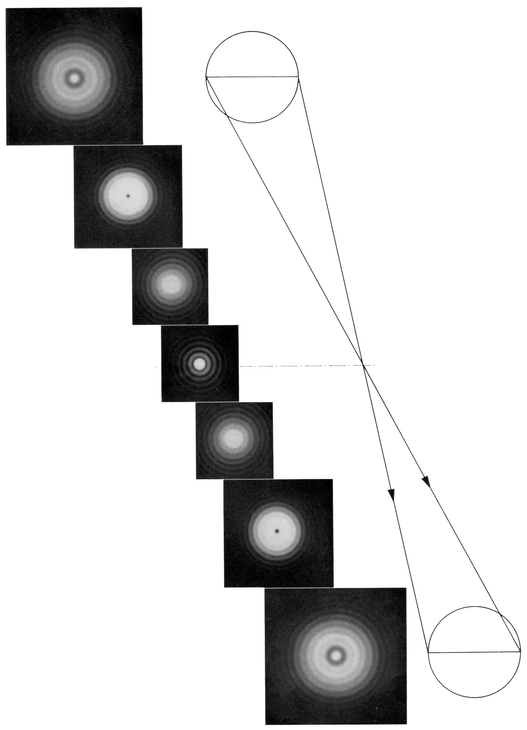
Fig. 8.2.10-1. Diffraction by a circular aperture as a function of defocus for no aberration
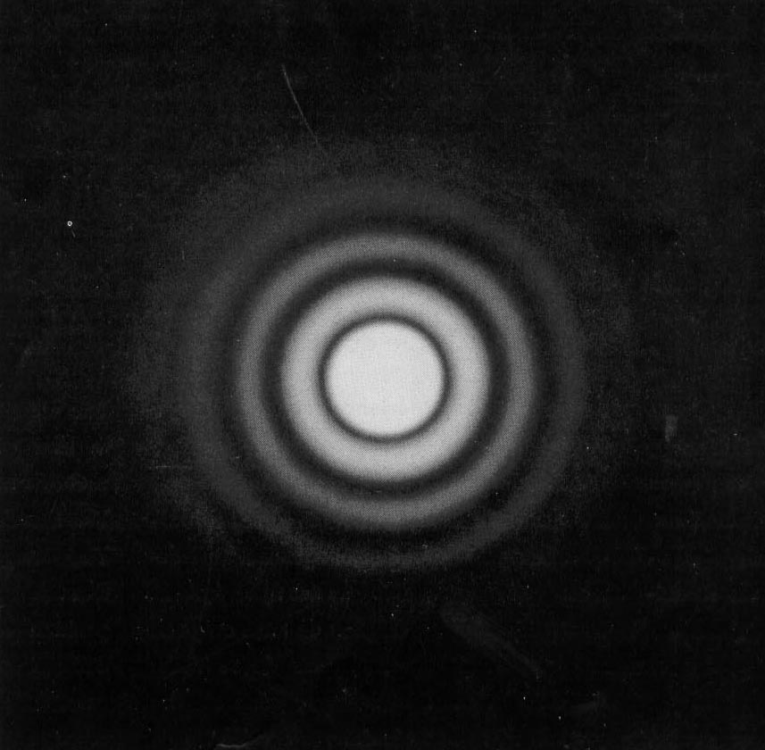

Airy Disk

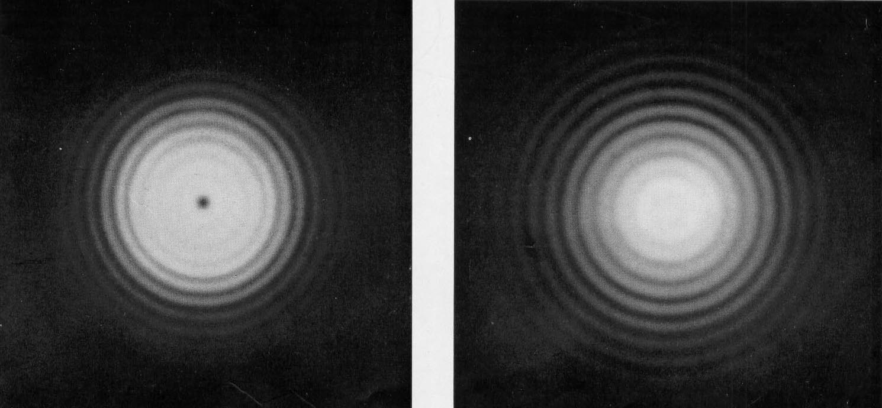

1 wave defocus Less than 1 wave defocus

Fig. 8.2.10-2. Diffraction by a circular aperture in the presence of defocus.

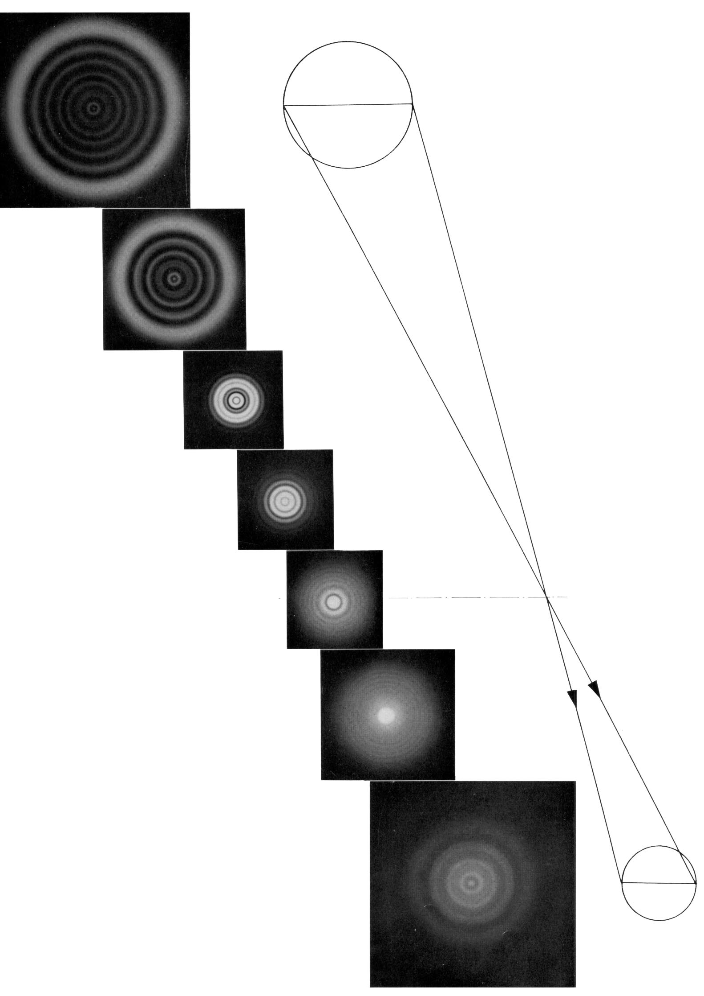
Fig. 8.2.10-3. Diffraction by a circular aperture as a function of defocus for third-order spherical aberration

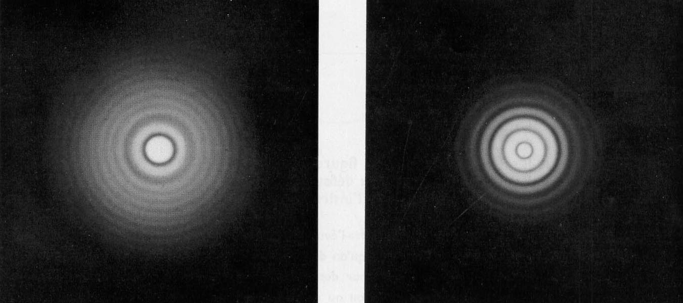
Paraxial Focus Small distance inside paraxial focus

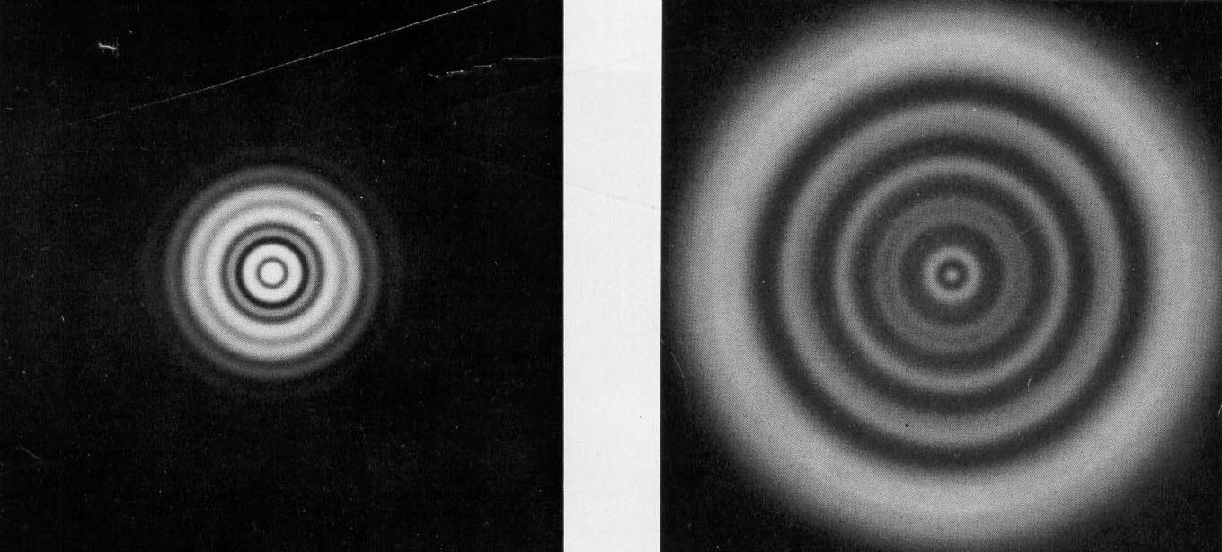

Moderate distance from marginal focus Immediate neighborhood of marginal focus

Fig. 8.2.10-4. Diffraction by a circular aperture in the presence of third-order spherical aberration.

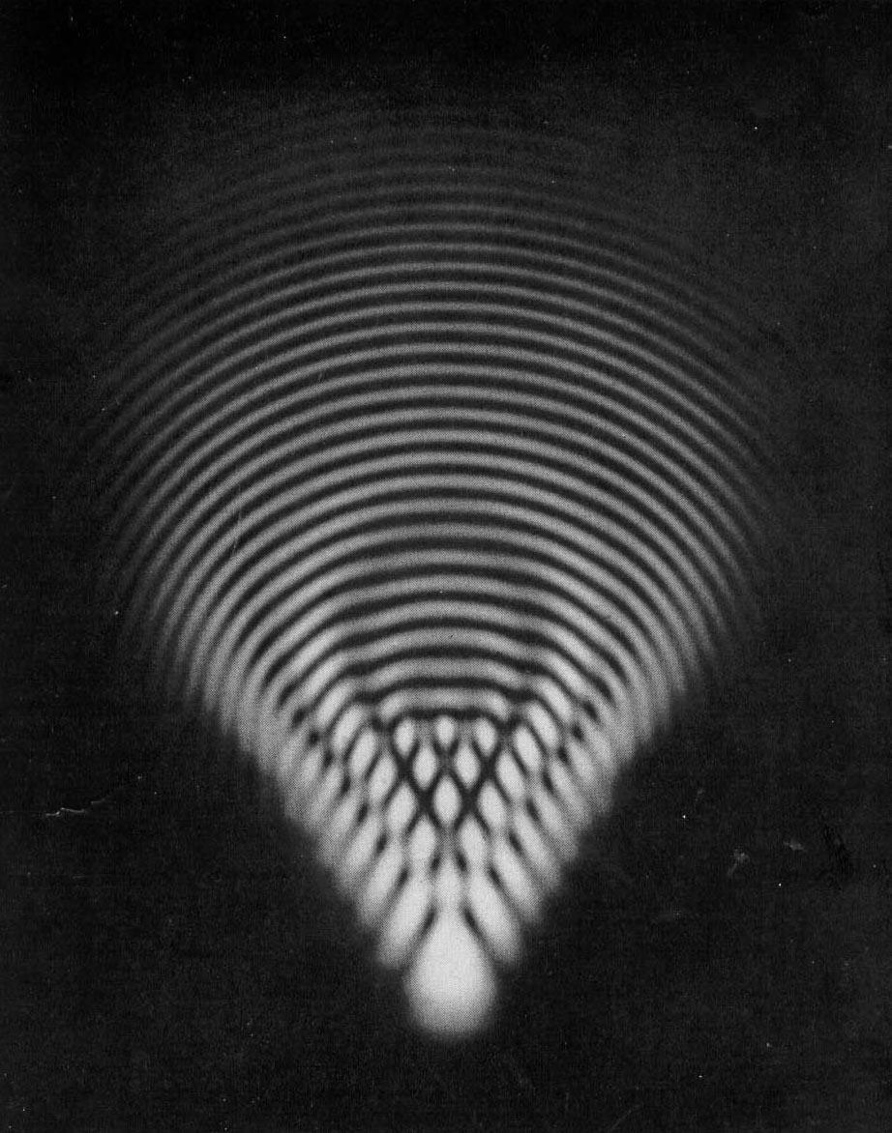
6 λ
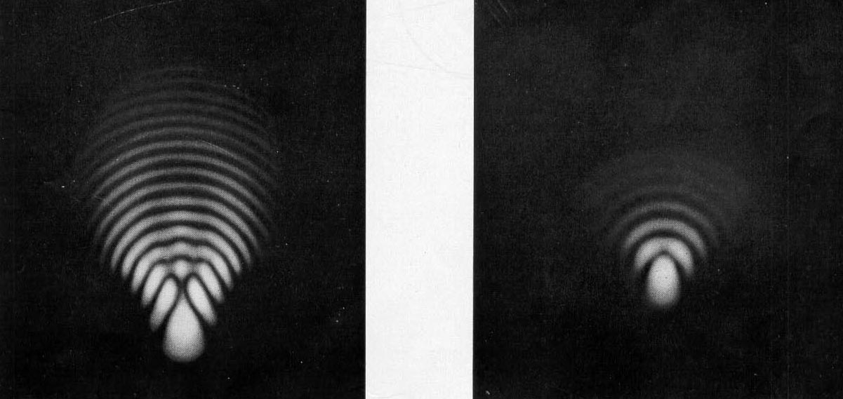

2.5 λ 1 λ

Fig. 8.2.10-5. Diffraction by a circular aperture in the presence of third-order coma.

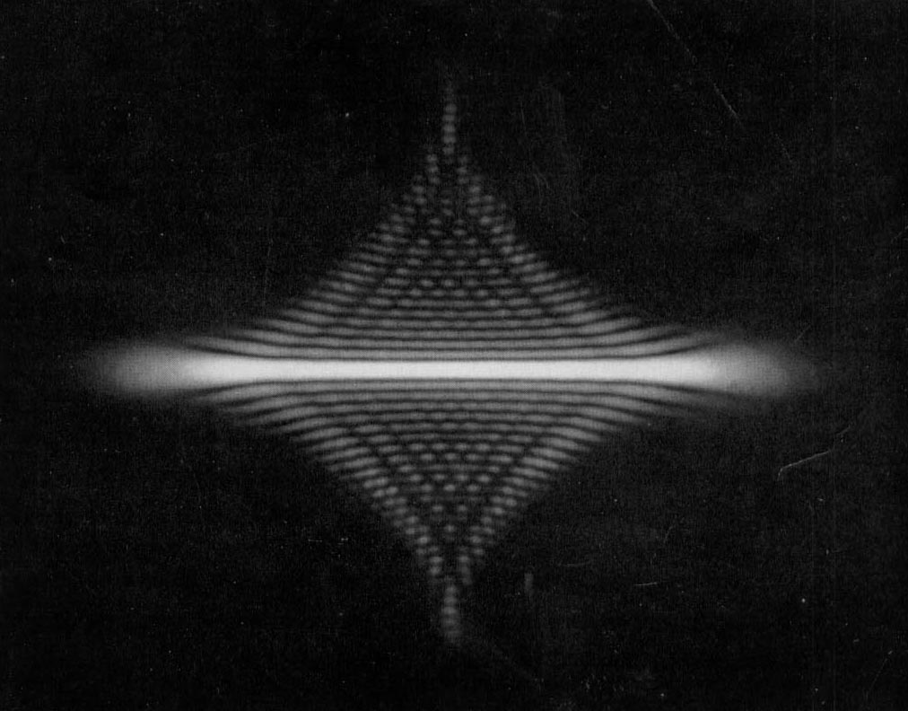

7 λ

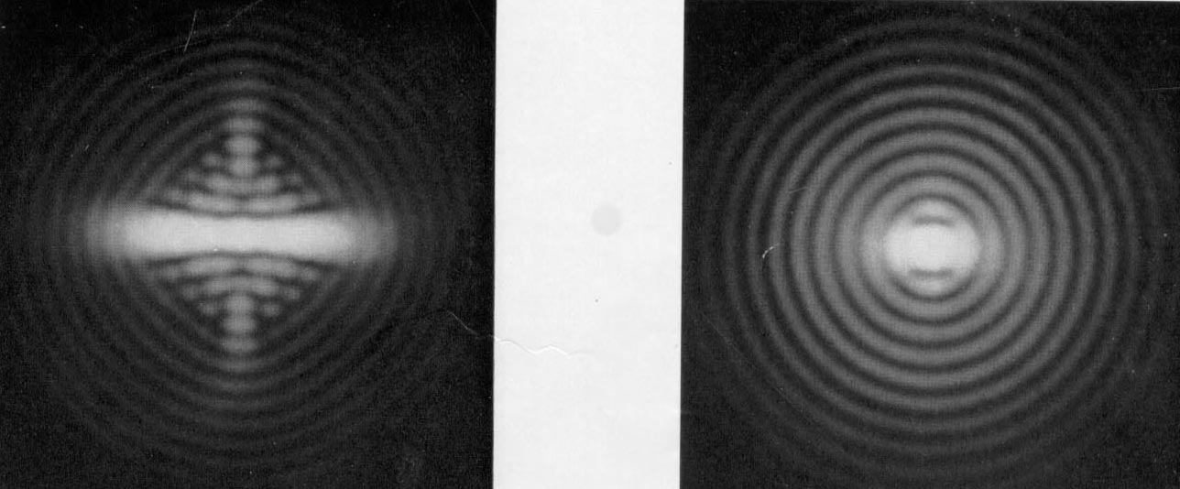
1.5 λ 0.23 λ

Fig. 8.2.10-6. Diffraction by a circular aperture in the presence of astigmatism.

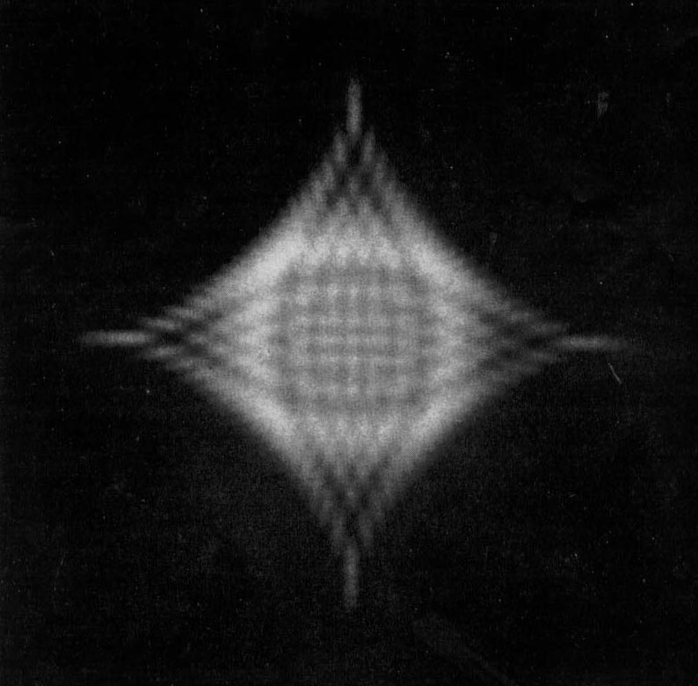

7 λ

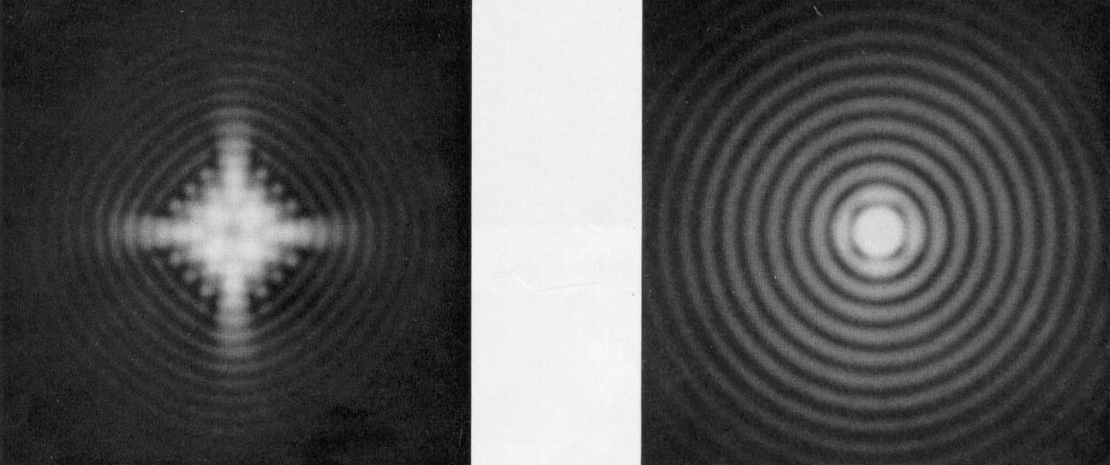
1.6 λ 0.23 λ

Fig. 8.2.10-7. Diffraction by a circular aperture in the presence of astigmatism in the neighborhood of the circle of least confusion.

