Ring Resonator For Laser Striping.

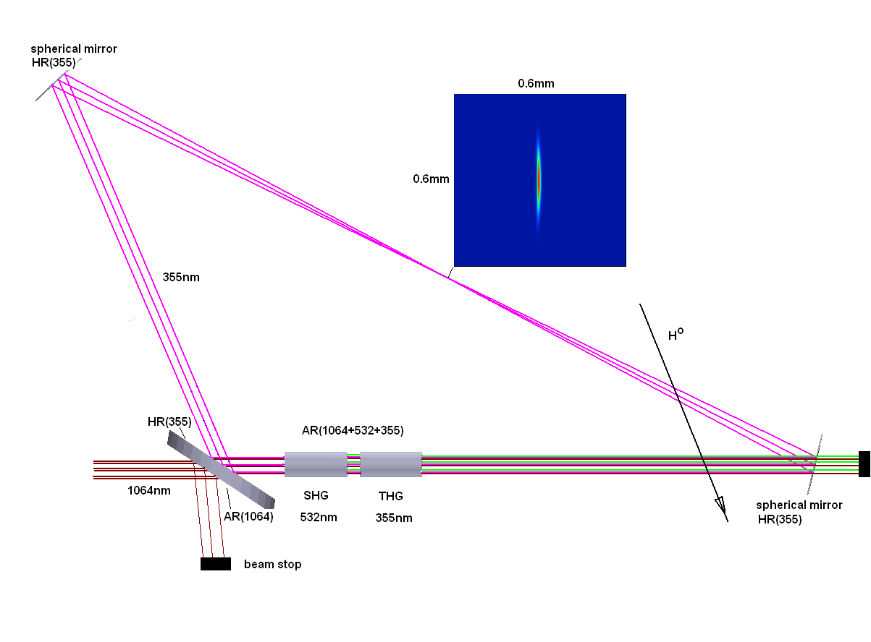
Fig.1 Ring resonator with two nonlinear crystals for generation of second and third harmonics.

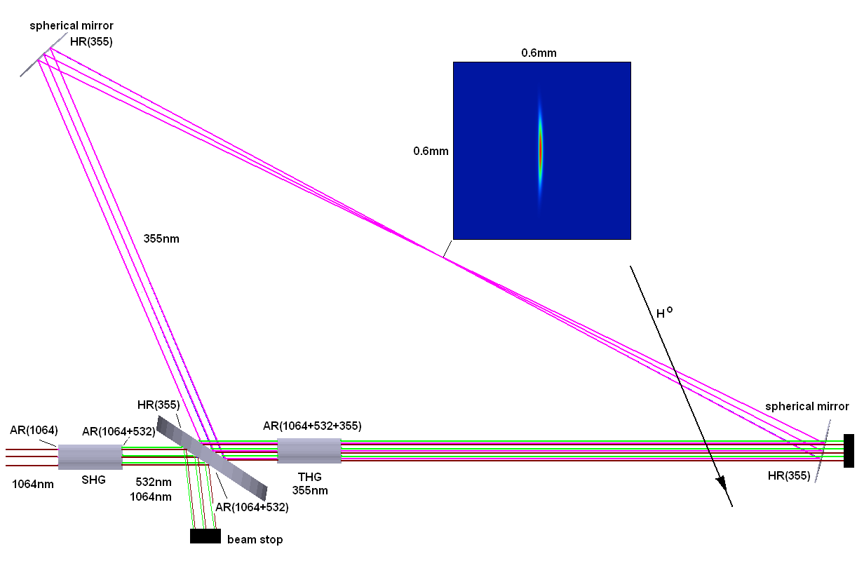
Fig.2 Ring resonator with one nonlinear crystal for generation of third harmonic.

Parameter Spec Measurement Technique:

Wavelength = 355nm (Visual confirmation)
Energy = 30 uJ, 160-180 mJ (4025 pulses), 40 uJ (micropulse)

Pulse Duration = 10 ms (Measured at 10 ms on an oscilloscope)

Micropulse Width = 70ps IR, = 50 ps UV (Autocorrelator to measure IR pulse waveform Temporal Profile - flat envelope)

Measured at 10 ms on an oscilloscope. Micropulse will be measured at Calmar.

Beam Diameter ~5mm (Burn Paper measurement Spatial Profile)

Beam code measurement 1064 and 355

Beam Divergence ? (Burn Paper measurement)

Repetition Rate = 10 Hz/402.5 MHz

Oscilloscope Shot to Shot Stability = 3% RMS for pulse envelope.

At 355nm from 100 shots

Time jitter = 8 ps (will be measured by Calmar Shot-to-shot stability)

148.8 mJ - 174.6 mJ in 1000 shot (variation 2.6%)

Water - Two pairs of inlets/outlets

Electric Power Supply - Single phase, 220V, 30 A (two connectors)

Dimension: 7ft (L) x 2ft (W) x 1 ft (H)

