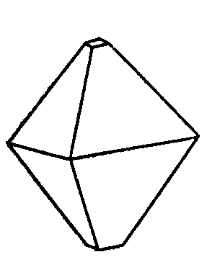  Crystals  of Siberia  Solutions for laser systems  CRYSTALS of SIBERIA Ltd.  43, Russkaya str.  Novosibirsk  630058 Russia  Tel/Fax: + 7 383 330 90 44  oksana@ssc.nsib.ru | Attn: I. N. Nesterenko

QUOTATION

Item 1.
LBO crystal, SHG
Dimensions: 8 mm(W) x 8 mm(H) x 25 mm(L)
Cutting angle:
Theta: 90 degrees
Phi: 11.6 degrees
Anti-reflection Coating:
DBAR@1064+532 nm both sides
Quantity: 1 element
Price: $2070 per element

Item 2.
LBO crystal, THG
Dimensions: 8 mm(W) x 8 mm(H) x 25 mm(L)
Cutting angle:
Theta: 90 degrees
Phi: 37.2 degrees
Anti-reflection Coating:
DBAR@1064+532 nm sides1
DBAR@355 nm sides2
Quantity: 1 element
Price: $2070 per element

The specifications for crystals are guaranteed:
Tolerance of dimensions (aperture): +0.1/-0.1 mm
Tolerance of dimensions (length): +0.5/-0.3 mm
Accuracy of Orientation: < 0.5 degrees
Optical surface quality: ≤10/5 scratch/dig
Flatness (at λ=633nm): ≤λ/8
Parallelism: ≤ 20 arcsec
Perpendicularity: ≤ 15 arcmin

Delivery insurance, packing and custom charges:$150-200
Terms of price: CIP USA via UPS delivery agent

Payment Terms: 30 days after invoice date, but after receipt of goods at the carryover

Please, contact for more information.

Best regards,
Oksana V. Kizko,
Director

